# If else in C++

1. Practice 01

Practice 02:

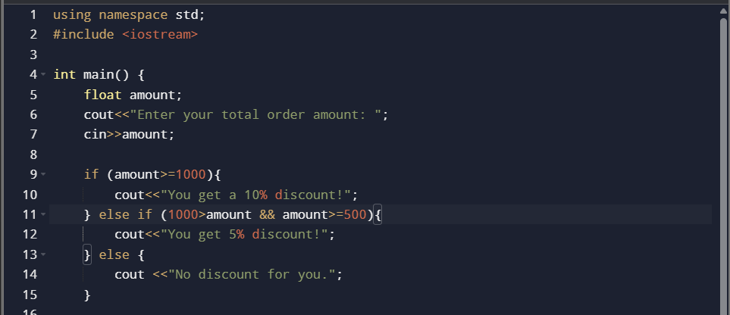

Practice 03:

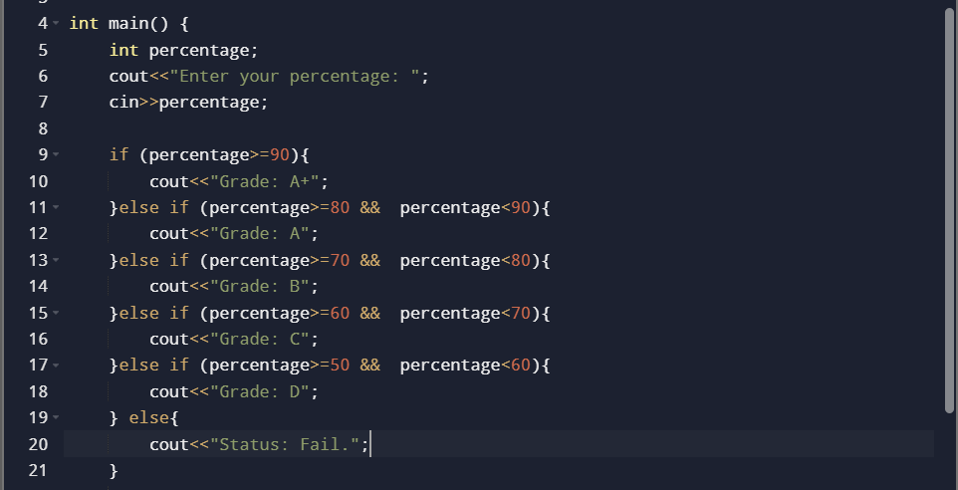

Task 02

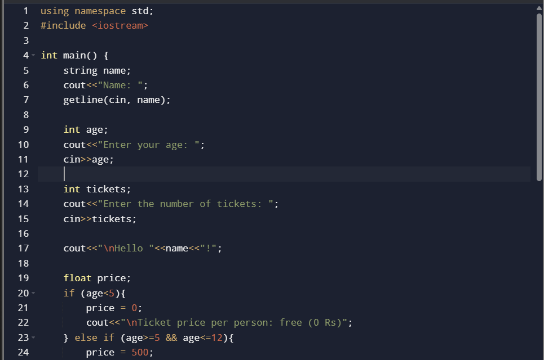

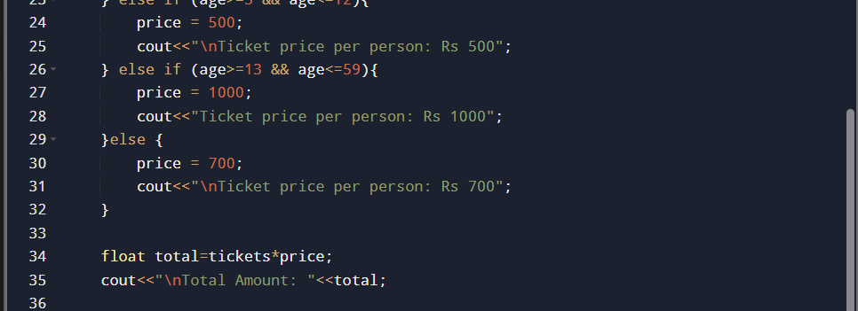

Task 03:

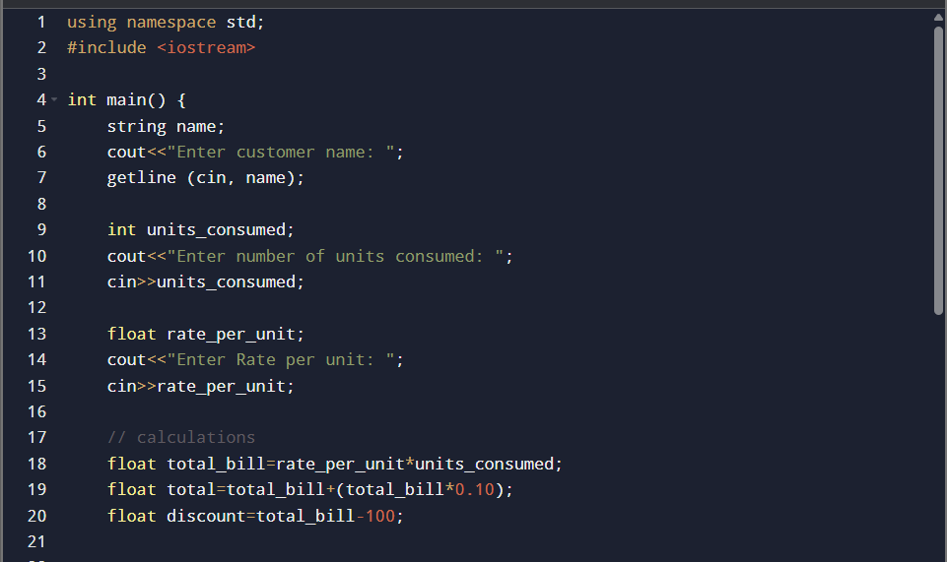

Task 04:



